**Topics: Normal distribution, Functions of Random Variables**

1. The time required for servicing transmissions is normally distributed with *μ* = 45 minutes and *σ* = 8 minutes. The service manager plans to have work begin on the transmission of a customer’s car 10 minutes after the car is dropped off and the customer is told that the car will be ready within 1 hour from drop-off. What is the probability that the service manager cannot meet his commitment?
2. 0.3875
3. 0.2676
4. 0.5
5. 0.6987

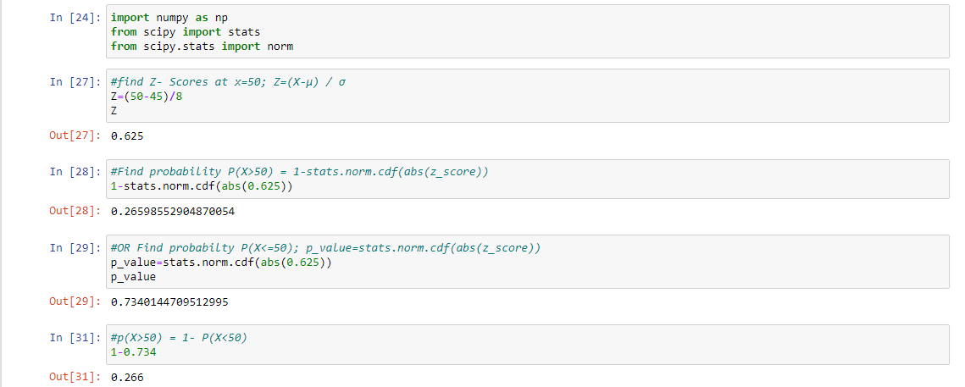Ans:-

1. The current age (in years) of 400 clerical employees at an insurance claims processing center is normally distributed with mean *μ* = 38 and Standard deviation *σ* =6. For each statement below, please specify True/False. If false, briefly explain why.
2. More employees at the processing center are older than 44 than between 38 and 44.

Ans:- Mean = 38

SD = 6

Z score = (Value - Mean)/SD

Z score for 44 = (44 - 38)/6 = 1 => 84.13 %

=> People above 44 age = 100 - 84.13 = 15.87% ≈ 63 out of 400

Z score for 38 = (38 - 38)/6 = 0 => 50%

Hence People between 38 & 44 age = 84.13 - 50 = 34.13 % ≈ 137 out of 400

Hence More employees at the processing center are older than 44 than between 38 and 44. is FALSE

1. A training program for employees under the age of 30 at the center would be expected to attract about 36 employees.

**Ans:-** Z score for 30 = (30 - 38)/6 = -1.33 = 9.15 % ≈ 36 out of 400

Hence A training program for employees under the age of 30 at the center would be expected to attract about 36 employees - TRUE

1. If *X1* ~ *N*(μ, σ2) and *X*2 ~ *N*(μ, σ2) are *iid* normal random variables, then what is the difference between 2 *X*1 and *X*1 + *X*2? Discuss both their distributions and parameters.

**Ans:-** As we know that if X ∼ N(µ1, σ1^2 ), and Y ∼ N(µ2, σ2^2 ) are two independent random variables

then X + Y ∼ N (µ1 + µ2, σ1^2 + σ2^2), and X − Y ∼ N (µ1 − µ2, σ1^2 +σ2^2). Similarly, if Z = aX + bY, where X and Y are as defined above, i.e Z is linear combination of X and Y, then Z ∼ N (aµ1 + bµ2, a^2σ1^2 + b^2σ2^2).

Therefore, in the question

2X1~ N (2 u,4 σ^2) and

X1+X2 ~ N (µ + µ, σ^2 + σ^2) ~ N (2 u, 2σ^2)

2X1-(X1+X2) = N (4µ,6 σ^2)

1. Let X ~ N(100, 202). Find two values, *a* and *b*, symmetric about the mean, such that the probability of the random variable taking a value between them is 0.99.
2. 90.5, 105.9
3. 80.2, 119.8
4. 22, 78
5. 48.5, 151.5
6. 90.1, 109.9



a = 48.48 and b = 151.52

1. Consider a company that has two different divisions. The annual profits from the two divisions are independent and have distributions Profit1 ~ N(5, 32) and Profit2 ~ N(7, 42) respectively. Both the profits are in $ Million. Answer the following questions about the total profit of the company in Rupees. Assume that $1 = Rs. 45
2. Specify a Rupee range (centered on the mean) such that it contains 95% probability for the annual profit of the company.
3. Specify the 5th percentile of profit (in Rupees) for the company
4. Which of the two divisions has a larger probability of making a loss in a given year?

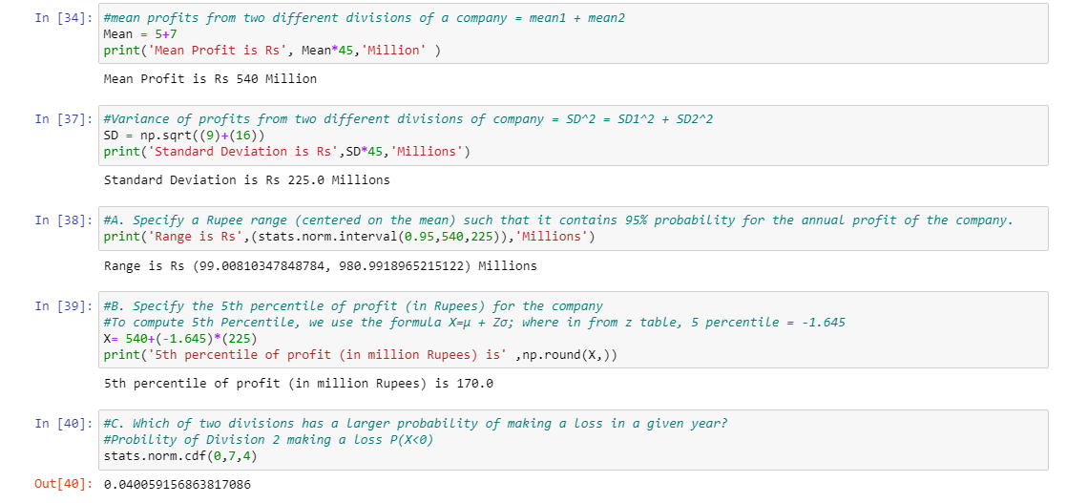Ans:-

1. Range is Rs (99.00810347848784, 980.9918965215122) in Millions
2. To compute 5th percentile, we use the formula X = μ + Zσ; wherein

from z table, 5th percentile = -1.645 X= 540+(-1.645) * (225)

Therefore, 5th percentile of profit (in Million) is 202.05 million

1. Probability of Division 1 making a loss P(X<0) **0.047**

Probability of Division 2 making a loss P(X<0) **0.040**